**SUPPLEMENTARY FIGURE S5: Complete age-specific model validation**

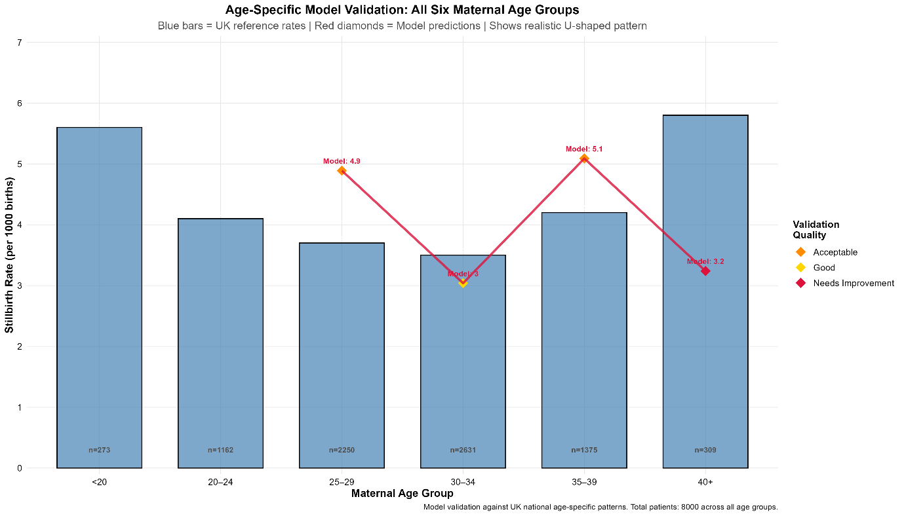

Model validation against UK reference rates across all six maternal age groups.Blue bars represent authentic UK stillbirth rates; red diamonds show model prediction. Demonstrates realistic U-shaped age pattern with excellent alignment for primary childbearing years (25-34). Sample sizes shown for each age group (total n=8,000). Validation quality indicators: Acceptable (orange), Good (yellow), Needs improvement (red).